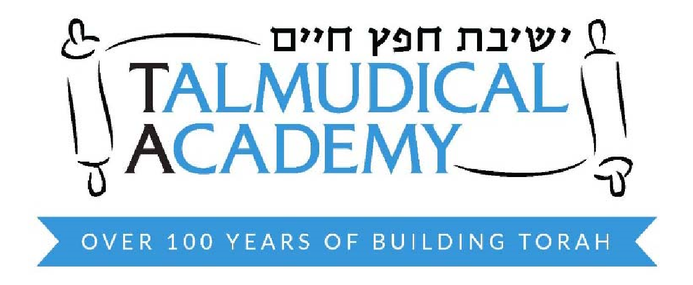

TALMUDICAL ACADEMY OF BALTIMORE, INC. ---
CAFETERIA PLAN
CAFETERIA PLAN FOR NON-EMPLOYER SPONSORED GROUP DENTAL PLAN

The school has a non-employer sponsored group dental plan. This is a request to participate in this plan for the 2021-2022 school year. The rates are as follows:

Family $126.00
Husband & Wife $65.00
Individual $33.00

= = = = = = = = = = = = = = = = = = = = = = = = = = = = = = = = = = = = = = = = = = = =

I authorize the school to pay on my behalf my dental premiums that are a reduction from my compensation.

I authorize the school to make the adjustment to comply with the above paragraph if the premium changes mid-year and the plan administrator allows for changes, the increase or decrease, as the case may be. If the plan administrator does not allow for changes then the additional amount will be deducted from my salary after taxes have been taken out.

________________ | _____________________________ | ________
(print) Employee Name | Employee Signature | Date
SANDY GUTTENBERG | By: __________________________ | ________
Plan Administrator | TALMUDICAL ACADEMY | Date
 | Of Balt., Inc./Plan Administrator

